Whoopie Pies

Don’t even look at how many calories are in these!

Serves 16 – Prep. time 15 min. – Cooking time 15 min.

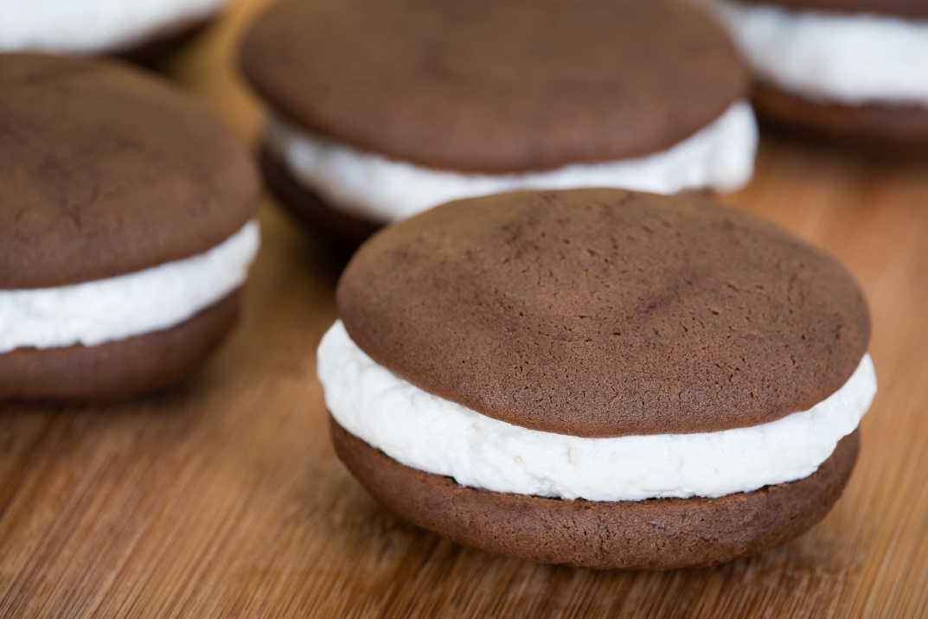

Ingredients
For the cookies
½ cup unsalted butter
1 cup brown sugar, packed
1 teaspoon instant coffee
1 teaspoon baking powder
½ teaspoon baking soda
1 teaspoon salt
1 teaspoon vanilla extract
1 large egg
½ cup cocoa powder
2 cups all-purpose flour
1 cup milk

For the frosting layer
1 cup shortening
1 cup confectioners sugar
1 ⅓ cups marshmallow fluff
¼ teaspoon salt
1 teaspoon vanilla extract

Directions
- Preheat the oven to 350°F and coat two baking sheets with cooking spray.
- In a mixing bowl, beat the butter with the sugar, coffee, baking powder, baking soda, and salt.
- Add the vanilla and eggs, and mix well. Fold in the cocoa.
- Add the flour in increments, alternating with the milk.
- Using a ¼ cup measure, scoop the dough onto the prepared baking sheets, leaving lots of room between them.
- Bake the cakes for about 15 minutes, until they are firm to the touch. Cool them on the pan, but remove them carefully while they are still lukewarm.
- Beat the filling ingredients together until smooth. Divide it among half the cookies, spreading it on the flat side. Top with the other half of the cookies.

Nutrition per serving
Calories 390, Fat 21 g, Carbs 49 g, Sugar 27 g,
Protein 7 g, Sodium 260 mg

Healthier Whoopie Pies

A healthier version full of the luscious flavors of the original! It will soon become a family’s favorite!

Serves 16 – Prep. time 15 min. – Cooking time 10 min.

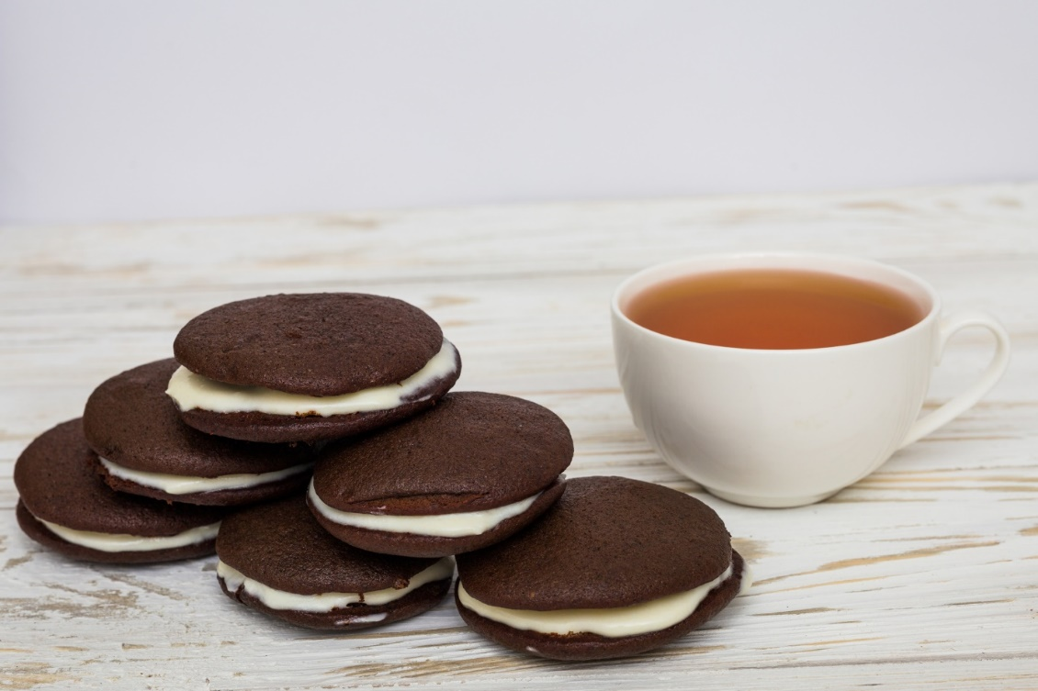

Ingredients
For the cookies
⅓ cup canola oil
¾ cup packed light brown sugar
1 large egg
1 teaspoon vanilla extract
1 ½ cups white whole wheat flour
⅓ cup unsweetened cocoa powder
¾ teaspoon baking powder
¾ teaspoon baking soda
¾ cup skim milk

For the frosting layer
4 ounces cream cheese
¼ cup granulated sugar
1 cup light whipped topping
Directions
- Preheat the oven to 350°F and coat two baking sheets with cooking spray.
- In a mixing bowl, beat the oil with the sugar until well combined. Add the egg and vanilla and mix well.
- In a separate bowl, combine the flour, cocoa, baking powder, and baking soda.
- Add the flour mixture to the wet ingredients in increments, alternating with the milk.
- Scoop the dough onto the prepared baking sheets, using about 2 tablespoons at a time, leaving lots of room between them.
- Bake the cakes for about 8–10 minutes, until they are firm to the touch. Cool them on the pan, but remove them carefully while they are still lukewarm.
- Beat the filling ingredients together until smooth. Divide it among half the cookies, spreading it on the flat side. Top with the other half of the cookies.

Nutrition per serving
Calories 176, Fat 8.2 g, Carbs 27.1 g, Sugar 14.6 g,
Protein 3.2 g, Sodium 116.6 mg

Recipes are from Louise Davidson Desserts Two Ways Favorite Dessert Recipes Made Two Ways Classic and Healthier. Click here to learn more

